Substance use Survey

Vision Document

Name: Michael Harrington
ID: C00296932
Supervisor: CM

Start Date: Monday 19th January 2026

Table of Contents

Brief Overview: 2
Functional Requirements: 2
DSM-5, DAST-10 and ASSIST 3
Target users/Platform: 4
Context Diagram: 5
Main Risks 5
Iteration Plan: (Subject to change) 6

Brief Overview:
This project is a drug Addiction survey that complies with GDPR rules to give information to Patients based on their state (e.g. risk of relapse). This project will contain 2 separate surveys each surveying separate addictions, one for prescribed drugs and another for alcohol abuse. These tests can be retaken daily or weekly to update a graph generated from the results and to see the patients progress.
Doctors would also be able to login to view the raw answers given by the Patients as well as the graph generated based on their answers.

Functional Requirements:
- Questions presented must be medically approved (DSM-5, DAST-10, ASSIST)
- Must use multiple choice questions to allow for a variety of results based exactly on the status of the user.
- Allow Patients to skip questions that are non-mandatory or questions that don't apply to the Patient.
- Give the patient a score and generate a graph based on their results.
- Offer feedback based off of the Patients answers
- Ability to login so tests can be retaken to monitor progress
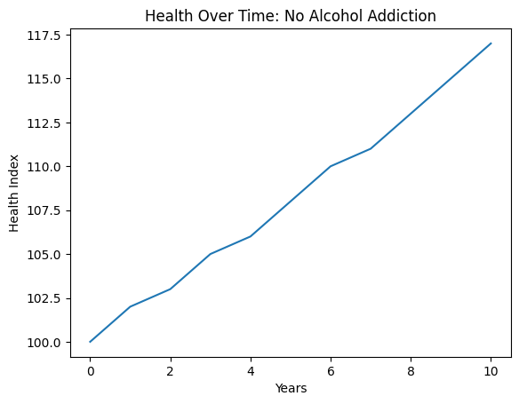
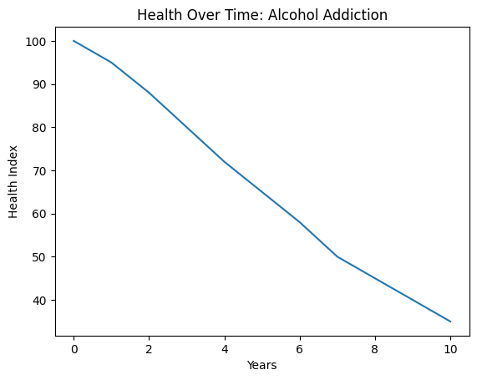
- Allow ONLY Doctors to login and access the answers and info of the Patients that take the survey.

- No Alcohol Addiction graph indicates that the health of an individual will increase when they are not addicted to alcohol.

- Alcohol Addiction graph indicates that the health of an individual will decrease when they are addicted to alcohol.

DSM-5, DAST-10 and ASSIST

DSM-5 or the Diagnostic and Statistical Manual of Mental Disorders is a set of criteria for diagnosing substance use disorders. It uses a severity scale of mild, moderate and severe.

DAST-10 or the Drug Abuse Screening Test is a 10 question screening questionnaire for drug abuse. It asks the best 10 questions to quickly identify any potential drug problems and uses a scoring system of low, moderate, substantial and severe.

Finally, ASSIST or the Alcohol, Smoking and Substance Involvement Screening Test is an examination that tests for the use of many substances developed by the World Health Organisation.

Non-Functional Requirements:
- A clear privacy policy
- GDPR (Non-hackable)
- PC, mobile and tablet friendly
- Disclaimers that results are “not a diagnosis”
- No Tracking data without consent.

Target users/Platform:

The target users for this survey are people who are currently addicted to drugs or are recovering from a previous addiction to track their current state as well as their progress. By taking the survey each week, the graphs can be viewed as a progress report.

The patient must be able to access the website on Desktop, Mobile and tablet. The Doctor needs only to access the website on Desktop.

Date: 21/01/2026
1. Key Partners  Hospitals/Counseling services  Government health agencies  Crisis hotlines  Public health organisations | 2. Key Activities  Developing an evidence based assessment of your state  Providing personalized feedback  Ensuring privacy and legal compliance  Offering referral and support pathways depending on results | 4. UNIQUE VALUE PROPOSITION  A confidential drug-use assessment  Reliable results  Gives recommended options (visit Hospital, doctor ETC) | 5. Customer Relationships  No long term commitment required  Fully anonymous | 7. TARGET  MARKET  People with drug addictions  People recovering from drug addictions to track progress
 | 3. Key Resources  Valid assessment frameworks(DAST-10 etc)  Secure platform |  | 6. Channels  Healthcare Referrals  website(desktop, mobile, tablet)
8. COST STRUCTURE  Compliance costs  Platform development/hosting  Content updates |  | 9. REVENUE STREAMS  Government health grants  Research collaborations

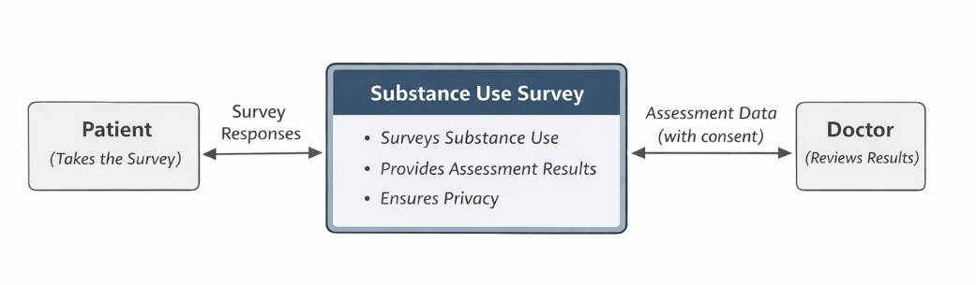
Context Diagram:

Patient:
- Takes Drug Addiction Survey
- Receives a status based on their
results

Doctor:
- Doctors can assess patients raw
Answers as well as graphs of their
Overall results across all surveys.

Main Risks
High Risk:
- Exposure of personal health data
- Data Breaches
- Accurate collection and safety of data

Misinterpretation of Results:
- Patients may treat assessments as a diagnosis
- results may give Patients false reassurance
Legal Risks:
- Non-compliance with GDPR health laws
- Improper data retention (loss of results)

Operation Risks:
- Loss of survey data
- Website down during peak usage

Iteration Plan: (Subject to change)
Iteration 1:
The website will be set up for desktop only allowing Patients to sign in and take 1 simplified survey based on an addiction to prescribed drugs. Upon completion the patient will be given the official assessment as per the questionnaire and level of their addiction as well as some general information about their results. The Mobile layout will be mostly complete containing a contact number, GDPR information, and an about us section detailing some information about addiction in general and the test. Security will also be a big factor early on so that will be implemented in the first iteration as well as storing the data of the patient results in the database for doctor use in the second iteration

None of the Doctor side will be developed until iteration as focusing on the Patient side gives a basis for the website.

Iteration 2:

On iteration 2, I will focus on the doctor side of things allowing a separate login for doctors. They will be able to view all the information of the patients that take the survey. I will also develop a second survey for the Patients to take which will be on alcohol abuse. A similar webpage will have to be created for the doctors with information that only they can access.

Iteration 3:

In the final iteration, I will generate graphs for the doctors to view based on the results of the patient’s survey results. I may also need to add an ai to allow for trend detection to display the information on the graphs accurately. I will add graphs to the main page (not based on real patients) of what an addict’s graph would look like compared to a non addict. Finally I would go over each page designing them to like appealing to use.

Note:
- MUST comply to GDPR
- Must have separate logins
- Must be secure from iteration 1

References
- DSM-5(DSM-5, 2022)
- DAST-10(The Drug Abuse Screening Test, 2020)
- ASSIST(Alcohol, Smoking and Substance Involvement Screening Test, 2023)

